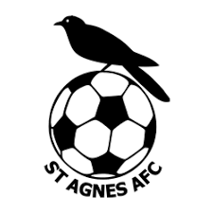

ST AGNES AFC requires parental consent before your child takes part in any sporting activities.

By completing and signing this form, you are confirming that you have read and understood the activities being offered to your child and agree with the measures the club has put in place to manage any risks, including its COVID-19 measures in line with current Government guidance.

A copy of the club’s risk assessment documentation will be available and on display at the event.

Please complete the self-check assessment below on the day of the event and bring this form with you:

Your child must not attend if they have:
- High Temperature (above 37.8C)
- New continuous cough
- Shortness of breath
- Sore throat
- Loss or change in normal sense of taste or smell
- Feeling generally unwell
- Persistent tiredness
- Been in close contact with/living with a suspected or confirmed case of COVID-19 in the previous 14 days
- People who have recently been on holiday have conformed to all quarantine requirements

Name of Child:
Date of Birth:
Parent/Guardian Name:
Mobile Number:

SIGNED: _______________________________ DATE:

